INTRODUCTION
Although Asia has registered the most rapid economic growth in the world in recent years, the continent is still the home to largest number of the people without access to electricity and clean cooking energy globally. In 2010, around 1.3 billion people were lacking electricity supply in the world, of which nearly half were in Asia. Despite the high economic growth in the region, it is estimated that around 30% of the people in South Asia and 21% of the people in South East Asia did not have access to electricity supply as of 2010. There is also a significant difference in the level of electrification rates across the rural and urban areas in the region. For example, only 61% of households were connected to electricity supply in the rural areas as compared to 91% in the urban areas in South Asia. Within the developing Asia, there are significant variations in terms of electricity access across different countries (see Figure 1).

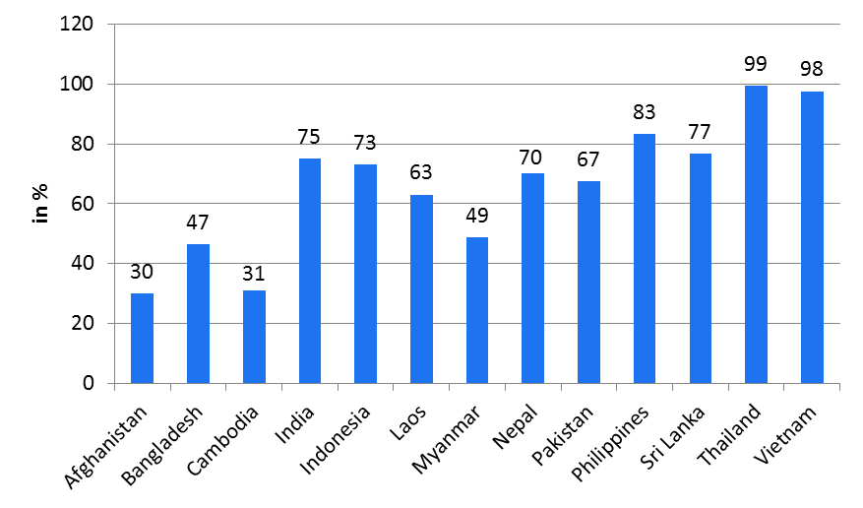
Figure 1: Access to Electricity in Selected Countries in 2010

Most energy access programs are focused on household’s access to basic electricity supply, and have paid inadequate attention to a more significant energy problem faced by the poor households, that is, their lack of access to cleaner energy or devices for cooking. Around 2.6 billion people of the world in 2010 had to rely on the use of traditional biomass for cooking, among which over 1.8 billion (about 70%) were in the developing Asia (IEA, 2012). In South Asia alone around 1.1 billion people were dependent on traditional biomass for cooking in 2010, which implies a share of around 42% in the total world’s population using traditional biomass. Figure 2 presents the variations in terms of percentage share of the population depending on traditional biomass for cooking in selected countries in developing Asia in 2010. There exists a large disparity in terms of households’ access to clean cooking energy between the rural and urban areas in developing Asia in that about 72% of the rural population still live without clean cooking facilities as compared to 17% of their urban counterparts. The disparity is much higher in South Asia, where 27% and 87% of the urban and

rural populations respectively are deprived of clean cooking facilities (IEA, 2012).

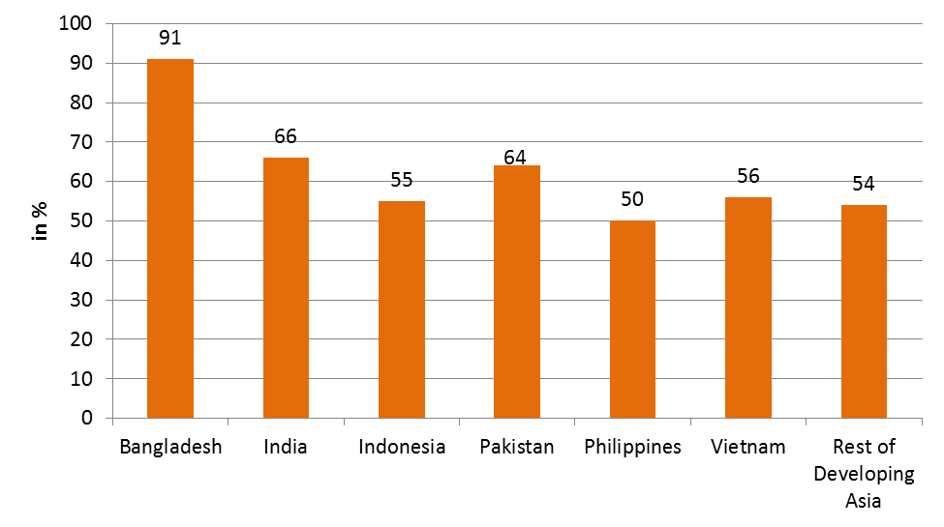
Figure 2: Share of Population depending on Traditional Biomass for Cooking in Selected Asian Countries

The United Nations has declared the decade 2014 2024 as the Decade of Sustainable Energy for All and has called upon member states “to galvanize efforts to make universal access to sustainable modern energy services a priority”. It has also expressed concern that even when energy services are available, millions of poor people are unable to pay for them, which highlights the need to address issues of both availability of clean energy and affordability of the poor to pay for it in pursuing the objective of universal access to energy (UN, 2012). In Asia, the Asian Development Bank (ADB) is leading the Energy for All Partnership that acts as a platform for collaboration between governments, civil society, and the private sector to share knowledge, build capacity, and develop energy projects. One of the activities of the ADB’s Technical Assistance Program titled “Enhancing Knowledge on Climate Technology and Financing Mechanisms” is to carry out a study that assesses growing energy demand of the poor as well as non-poor in rural and urban areas in Asia and the Pacific and to look at energy supply options that are both cost-effective and climate friendly. As part of this program, an analytical approach for sustainable energy access planning is being developed and a number of case studies are being conducted in the present project to determine sustainable and cost effective climate friendly options to supply energy for all at national and sub-national (district, village etc.) levels.

The proposed energy access planning (EAP) framework will have several features that are distinctive from the traditional electrification and energy planning frameworks: First, unlike the traditional energy planning and electrification frameworks, EAP will consider social inclusiveness even of the poorest households in terms of gaining access to electricity and other cleaner forms of energy to meet their basic energy needs for lighting, cooking and heating. Second, energy demand assessment in the EAP framework will consider basic energy needs of the poor in order to alleviate energy poverty while it uses econometric and other traditional approaches to assess the present and future energy demands in the case of non-poor households. Third, the EAP framework, as one of its integral part, will assess the financial implications and poor’s affordability to even the economically most cost effective options to supply them with electricity and other cleaner energy sources energy. Fourth, in determining the cost effective options for providing access to cleaner energy, the EAP framework will consider geographical information as to both the spatial distribution of households and local energy resources as well as the proximity of the user community to the national grid in the case of electricity supply. Fifth, the EAP framework will also analyze the sustainability, reliability, and acceptability of the cleaner energy options to ensure quality and sustainability of energy access (EA) programs at local levels. Furthermore, the EAP will generate crucial information on investment requirements, as well as co-benefits of EA and projects programs in terms of improvements in social wellbeing and environmental quality, greenhouse gas mitigation and reduction in energy inequality.

The EAP framework will prioritize investments opportunities for EA programs and projects based on incremental costs of energy access and other considerations, which can provide a sound basis for investment planning both to the national and donor agencies. As the framework allows EAP at the level of either a particular area/community or a number of areas/communities together, one can identify all the areas or communities, for which a specific resource or technology (e.g., micro-hydro) would be cost effective for providing energy access and rank them in terms of their financial indicators, levelized supply cost per kWh and number of users that could be served. Depending on an energy access target (e.g., number of people or households to be supplied with electricity), it would then be possible to develop an EA investment program that comprises a portfolio of EA projects either of a particular technology type (e.g., micro-hydro, solar) or of different kinds that could be implemented to meet the desired EA policy objective.

KEY ISSUES TO BE ADDRESSED:
The major issues that the studies under the present project will address are the following:
- Determining the least cost options for ensuring access to modern energy services to all households at a decentralized (e.g., village or district) level. The framework to assess the costs of available options will use demand assessment of the poor based on basic minimum electricity and cleaner cooking energy needs to alleviate energy poverty and that of the non-poor based on income and other determinants of demand. The framework will also consider local resources, their costs, availability, sustainability, benefits and impacts, adequacy and reliability. The methodology will incorporate an innovative incremental energy access cost approach in ranking the options and their potential to provide energy access.
- Assessment of the levels of financing/investment requirements for energy access.
- Assessment of the level of subsidies and/or other financial support schemes needed for making electricity and clean cooking fuels and associated energy using devices affordable to the poor.
- Analyzing the welfare-, energy security-, greenhouse gas emissions- and other implications of providing universal access to electricity and clean cooking fuels and related devices at a decentralized level.

PROJECT ACTIVITES:
The activities of the project include: development of a framework for energy access planning, implementation of the framework in the form of energy access planning case studies, local/ national capacity building and dissemination/ workshop. An incremental energy access program cost curve approach (described below) will be a center-piece of the EAP methodology.

THE ENERGY ACCESS PLANNING FRAMEWORK:
The energy access planning framework comprises of a number of assessments (see Figure 3) described as follows:

- Energy Demand Assessment: Demands for energy services (lighting, cooking, heating etc.) are assessed in terms of the basic minimum energy requirements in the case of the poor and in terms of income and willingness to pay in the case of other households. The level of energy requirement (or demand) will then be estimated based on the estimated service demands. The energy demand assessment will be aligned to the Sustainable Energy for All tracking framework with respect to minimum energy requirements. It will also incorporate electric load growth forecasts for the energy access planning period.
- Local Resources and Technology Assessment: The availability of decentralized (local level) energy resources and technology options as well as their magnitude and proximity to the household settlements in an area are assessed to estimate the adequacy and cost of using the resource and technology options for meeting the energy requirements in the medium and long term. The assessment methodology will use the GIS based information on available local energy resources for this purpose to the extent available.

- Availability Assessment: This assessment will focus on availability of centralized (grid) electricity supply network as well as availability of modern cooking fuels and related appliances in the proximity of the area targeted for the energy access program.

- Energy Poverty Assessment: This assessment will estimate the number of households below the energy poverty line and their energy consumption levels. To the extent possible, energy poor households below the energy poverty line will be further classified.

- Energy Inequality Assessment: Energy inequality will be assessed on the basis of the information on the distribution of households in different categories in terms of their clean energy consumption in an area. The assessment of a reduction in energy inequality with an energy access program will measure the benefit of the energy access program in the area.

- Affordability Assessment: This assessment will determine the amount that poor and other households can afford to pay for electricity and modern cooking fuels as well as the associated energy using appliances and installation costs (e.g., electrical wiring, lamps, biogas- and improved- cook stoves).

- Adequacy/Reliability Assessment: This assessment determines whether an energy supply option is adequate and reliable to meet the medium and long term energy demand in the area, where energy access program is to be implemented.

- Sustainability Assessment: The sustainability analysis of energy access programme will be conducted at the decentralized level for technical, economical, social, environmental and institutional dimensions taking into account the possible electrification programs and clean cooking options.
- Acceptability Assessment: This assessment ascertains if the local population, especially the poor, is willing to accept a modern energy commodity and technology option for a given price and the level of the users’ knowledge as to the durability and reliability of the option.

- Benefit/Impact Assessment: The potential impacts of increased access to modern energy services in an area are assessed in terms of environmental, health, and social (education/employment/reduction of human drudgery) benefits at the local level as well as energy security benefit at the national level and GHG reduction at the global level.

- Cost Assessment: It will determine the minimum total cost of providing modern energy and associated energy using devices to all in two different cases, i.e., (i) cost of providing modern energy to meet the basic minimum energy requirement and associated energy using devices of all households in the area and (ii) cost of providing modern energy based on demand assessment (considering income and affordability) except in the case of the poor to whom provision of energy at the basic minimum requirement will be considered. Also assessed will be the incremental cost of expanding energy access program to different areas (say villages) in a district (or different districts in a country). The concept of incremental energy access cost (IEAC) is illustrated in Figure 4, which illustrates an incremental energy access cost curve (IECC); In the figure H1, H2 etc. in the horizontal axis measure the number of households in areas A1, A2 etc. respectively and the vertical axis shows the corresponding IEAC. Similarly, another kind of IECC can also be developed if it is of interest to assess the IAEC of providing different levels of energy service to a given community or area as shown in Figure 5; in the figure, S1, S2, ..,Sn represent the level of end use energy service to be provided to the households and IC1, IC2,…,ICn represent the corresponding incremental energy access cost. The cost assessment methodology will also incorporate a GIS component, which will map human settlement patterns, load centers, existing and planned electricity distribution networks, commercial, industrial and social facilities. This will help in arriving at least cost options for providing energy access to specific geographical areas over a period of time in future.

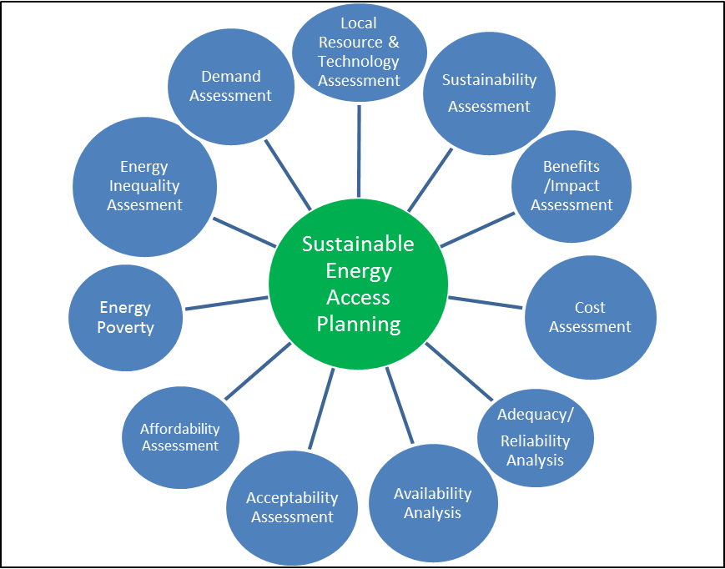
Figure 3: Methodological Framework

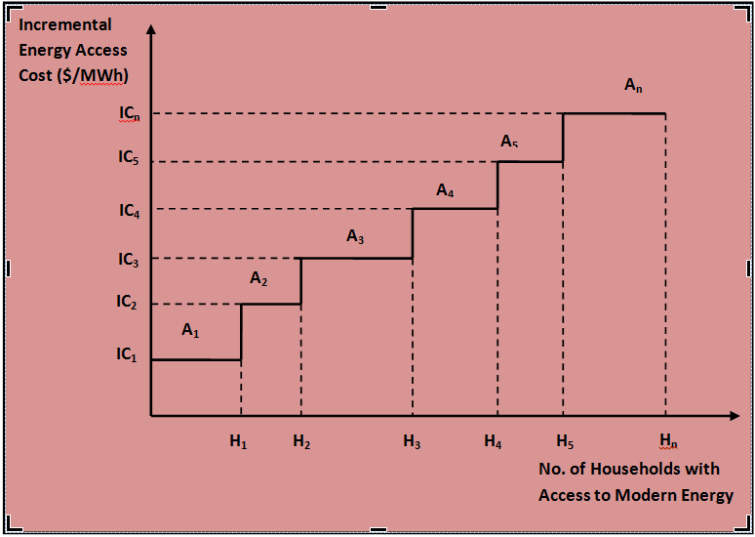
Figure 4: Concept of Incremental Energy Access Cost

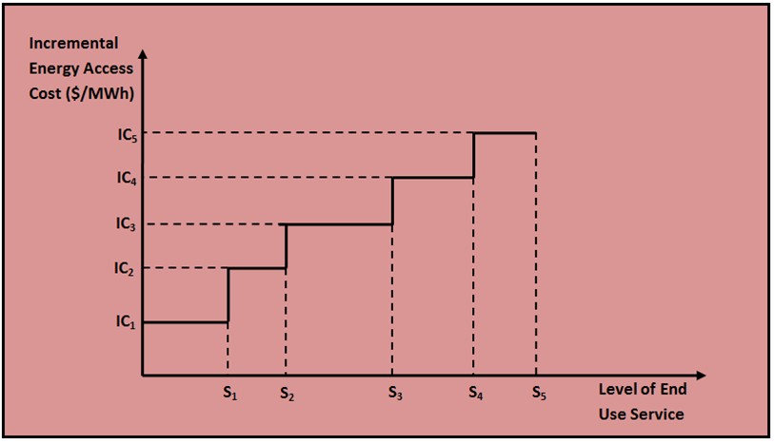
Figure 5: Increment Energy Access Cost Curve with varying levels of End Use Services Provided

KEY OUTPUTS:
Major outputs of the project activity will be two kinds of knowledge products:
- Development of a comprehensive framework for energy access planning, which will provide a sound basis for developing programs for sustainable and affordable supply for all at national and sub-national levels. The planning framework will generate an incremental energy access cost curve, which comes handy for the prioritization (from investment/implementation perspective) of the least cost options for providing clean and modern energy services to unserved populations among the areas or communities covered by the energy access planning activity. The framework can be used for planning EA in a number of geographical areas or communities within a country, in which case it can identify all the areas, where a particular type of energy supply option (e.g., micro/mini hydro, solar) would be cost effective; this would help make an investment portfolio of similar EA projects. The methodology also allows the government and/or interested donor agencies to obtain total investment needed by energy access programs for meeting alternative levels of energy end-use service requirements. This will assist governments to prioritize investments in energy access programs and also provide them with the tool to request assistance from international development partners. Both national and local governments can use the EAP methodology to generate project ideas, develop them into investment projects and prioritize them. It can then use that knowledge in making its own investment decisions or share it with international development partners.
- Case studies on developing sustainable energy access strategies and programs in selected districts of Nepal using the framework mentioned above. The case studies will provide information about the levels of investments required, incremental energy access program cost as well as energy security, climate and welfare implications of the energy access programs at decentralized levels. The case studies, in addition to generating the key information for energy access planning in the case study areas, are also expected to provide insights as to practical limitations of the energy access planning framework and thereby refine it further.

For more information, contact

Prof. Dr. Ram Manohar Shrestha
Study Team Leader
ram.m.shrestha@gmail.com

Jiwan Acharya
Senior Climate Change Specialist (Clean Energy)
Sustainable Infrastructure Division
Regional and Sustainable Development Department
Asian Development Bank
jacharya@adb.org
www.adb.org

